Chapter 7, Solution 5.

Using Fig. 7.85, design a problem to help other students to better understand source-free RC circuits.

Although there are many ways to work this problem, this is an example based on the same kind of problem asked in the third edition.

Problem

For the circuit shown in Fig. 7.85, find i(t), t>0.

2 Ω t=0
+
_

i

5Ω
24 V 4 Ω 4Ω

1/3 F

Figure 7.85 For Prob. 7.5.

Solution

Let v be the voltage across the capacitor.
For t <0,
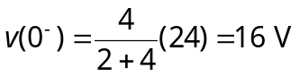
For t >0, we have a source-free RC circuit as shown below.

i

5Ω
4 Ω
+
v 1/3 F
–

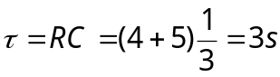
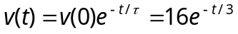V
